Medicine Inventory and Supplier Management System
Milestone 3 Completion Report
Stock & Expiry Monitoring • Alerts & Notifications • Inventory Analytics & Reporting

1. Introduction
The Medicine Inventory and Supplier Management System is a web-based application built to help pharmacies and medical stores manage their medicine stock, suppliers, purchase records, and day-to-day inventory operations from a single platform. Earlier milestones established the foundational structure of the system — the database schema, core medicine and supplier records, and basic stock-in/stock-out operations.
Milestone 3 builds on this foundation by adding the intelligence layer of the system: automated monitoring of stock and expiry conditions, real-time alerts and notifications, an analytics layer that summarizes inventory health, and the ability to generate and export inventory/expiry reports. These features move the system from a simple record-keeper to an active tool that proactively flags problems — such as medicines about to expire or stock running low — before they become critical, and gives the pharmacy owner a clear, data-backed view of overall inventory status.
This report documents the work completed under Milestone 3, the approach taken for each feature, and the screens that demonstrate the functionality working against live database data, as required for the Week 6 milestone review.

2. Objectives
The primary objective of Milestone 3 is to make the inventory system capable of monitoring stock and expiry conditions, generating meaningful alerts, providing analytics, and producing reports — all backed by actual data from the database and fully integrated with the frontend. Specifically, this milestone aims to:
- Track the expiry date of every medicine batch and automatically classify stock as fresh, near-expiry, or expired.
- Continuously compare current stock quantity against a defined reorder/threshold level to identify low-stock and out-of-stock medicines.
- Generate real-time notifications for low-stock and expiry conditions and deliver them through an in-app notification mechanism.
- Expose backend analytics APIs that calculate key inventory metrics such as total stock value, count of low-stock items, out-of-stock items, and items nearing expiry.
- Present these analytics visually on the dashboard so the pharmacy owner gets an at-a-glance summary of inventory health.
- Provide the ability to generate and export inventory and expiry reports for offline review, audits, or supplier follow-up.

3. Scope of Work Covered
The table below summarizes the tasks planned for this milestone and their completion status.
Task | Status
1. Expiry Tracking  Track expiry dates; identify near-expiry/expired medicines; display expiry status. | COMPLETED
2. Low-Stock Alerts  Identify below-threshold stock; handle out-of-stock items; display low-stock alerts. | COMPLETED
3. Notifications  Implement low-stock & expiry notifications; integrate the notification mechanism. | COMPLETED
4. Inventory Analytics  Backend analytics APIs for total stock, low-stock, out-of-stock and expiring counts; displayed on the dashboard. | COMPLETED
5. Report Generation  Generate inventory/expiry reports; provide report/export functionality. | COMPLETED

4. Implemented

4.1 Expiry Tracking
Every medicine batch stored in the database now carries an expiry date field. On each request, the backend computes the number of days remaining until expiry and classifies the batch into one of three statuses: Fresh, Near-Expiry (within the configured threshold window, e.g. 30/60/90 days), or Expired (expiry date has already passed).
This status is calculated live from the stored expiry date rather than a static flag, so it always reflects the current date. The frontend displays this status using color-coded badges (green/amber/red) in the medicine list and in a dedicated expiry-tracking view, making it easy for staff to spot batches that need attention.
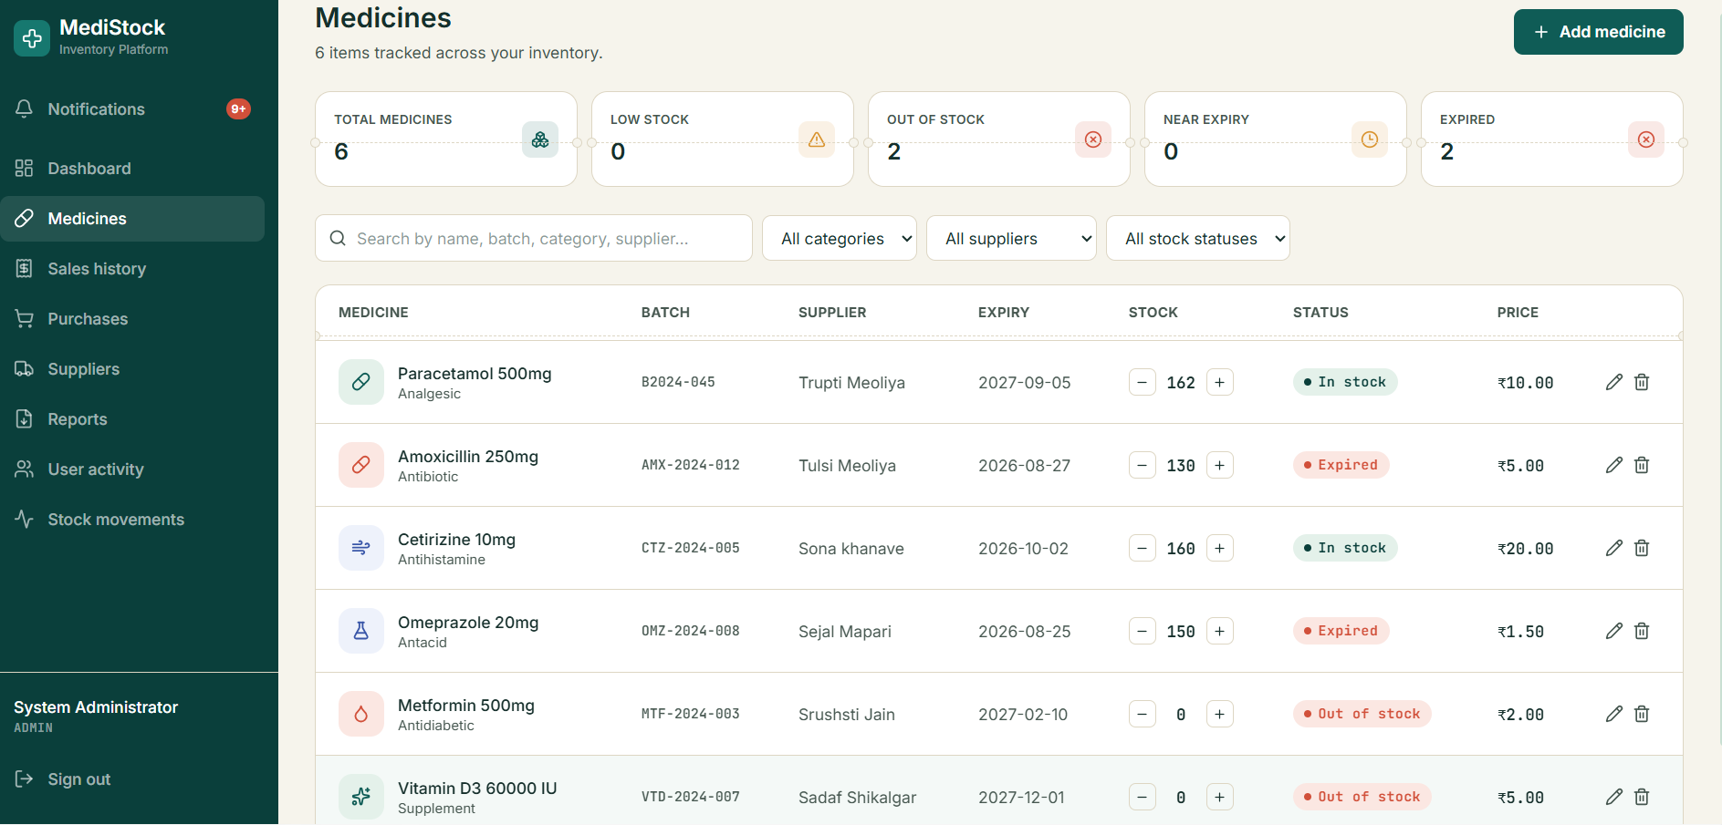
Fig 4.1 — Expiry tracking view: medicine list with expiry date, current stock and live status (In Stock / Low Stock / Out of Stock / Expired), plus KPI cards for Near-Expiry and Expired counts.

4.2 Low-Stock Alerts
Each medicine is configured with a minimum required stock level (reorder threshold). The system compares the current available quantity against this threshold to flag items as Low Stock, and flags items with a quantity of zero as Out of Stock.
These checks run against live database values whenever stock changes (e.g., after a sale or stock-in entry), so the alert list is always current. Out-of-stock items are highlighted distinctly from low-stock items on the frontend, since they require more urgent reordering action.
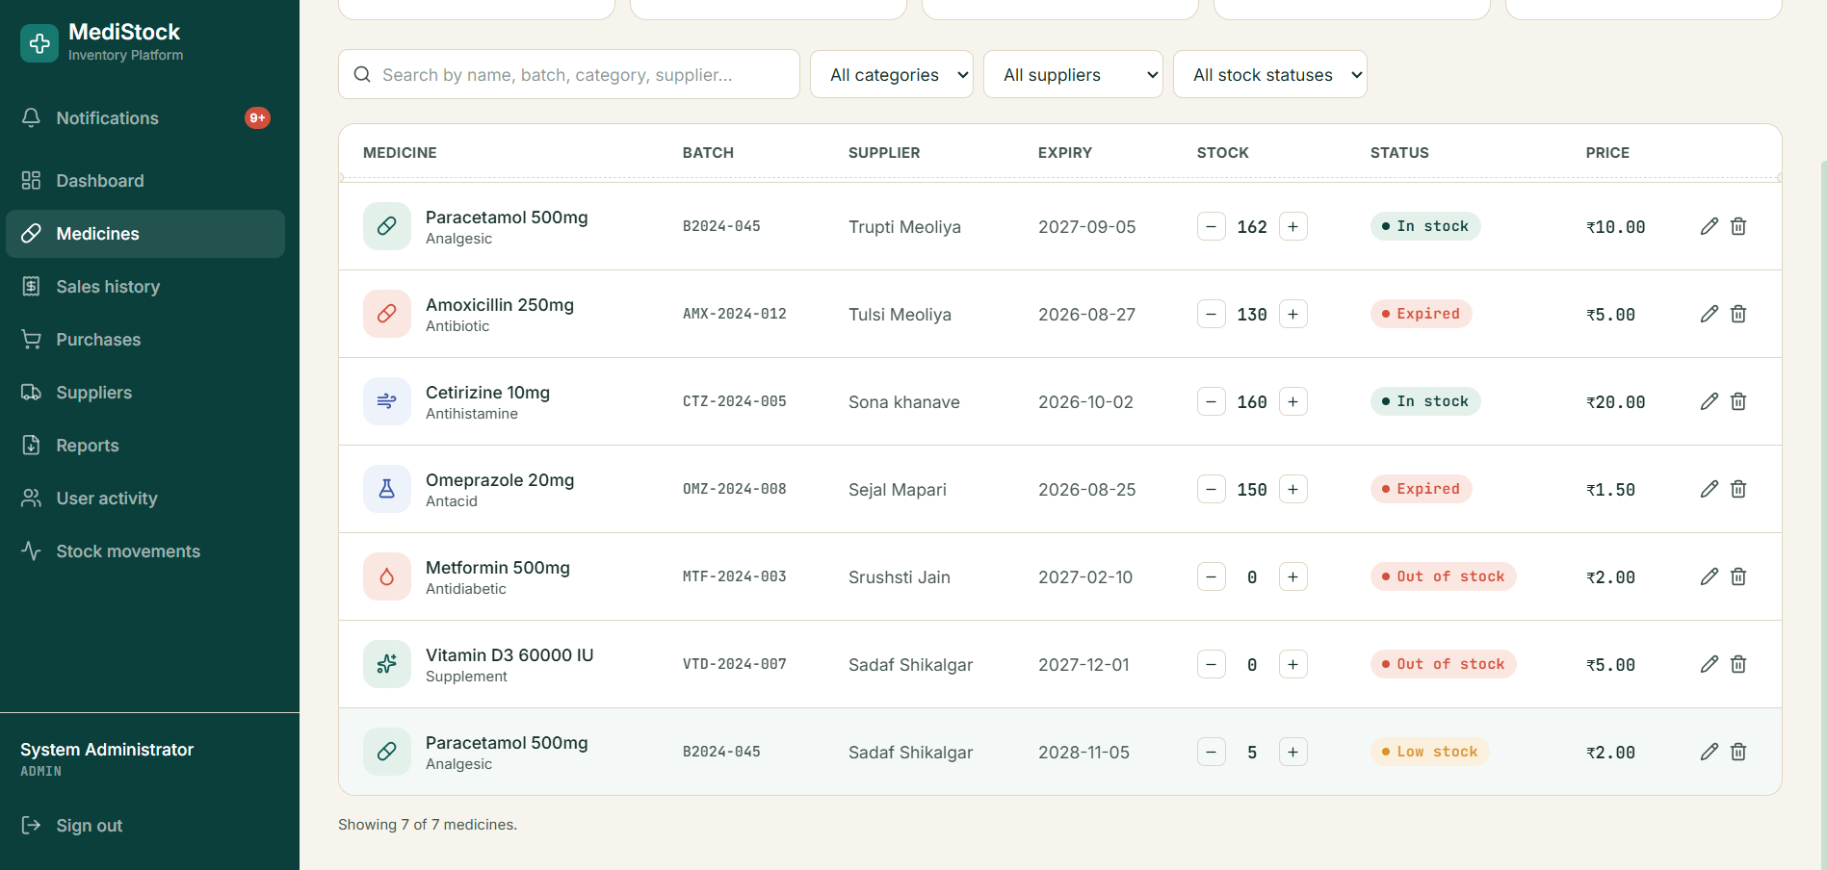
Fig 4.2 — Low-stock alert view: medicines below the required stock level are flagged "Low stock", and zero-quantity medicines are flagged "Out of stock".

4.3 Notifications
Low-stock and expiry conditions detected by the backend are converted into notification entries that are surfaced to the user through an in-app notification center (bell icon with a live unread count). Notifications are generated automatically whenever the underlying analytics detect a new low-stock, out-of-stock, near-expiry, or expired condition, avoiding duplicate alerts for the same ongoing issue.
Each notification links directly to the relevant medicine record, so a staff member can act on it immediately (e.g., reorder stock or remove an expired batch) without searching for it separately.
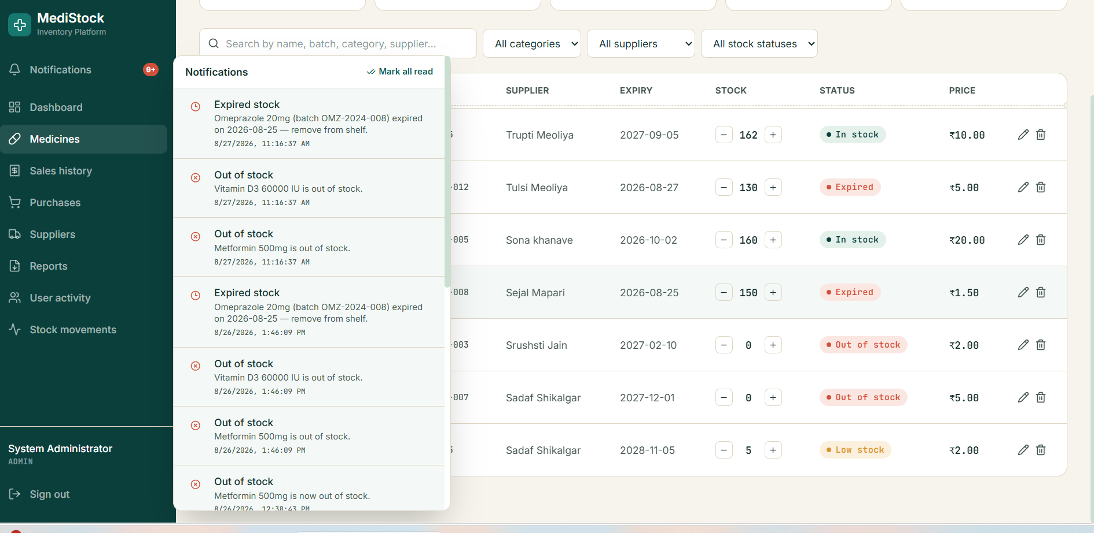
Fig 4.3 — In-app notification center: bell-icon dropdown listing expired-stock and out-of-stock notifications with timestamps, with a "Mark all read" action.

4.4 Inventory Analytics
A set of backend analytics APIs was implemented to summarize inventory health directly from database data. These endpoints calculate metrics such as total number of medicines, total stock quantity/value, count of low-stock items, count of out-of-stock items, and count of medicines nearing or past expiry.
These metrics are consumed by the dashboard and rendered as summary cards and charts, giving an at-a-glance view of overall inventory status without needing to open individual lists.
- Total stock count and estimated stock value
- Low-stock item count and out-of-stock item count
- Near-expiry and expired medicine counts
- Category-wise or supplier-wise stock breakdown (where applicable)
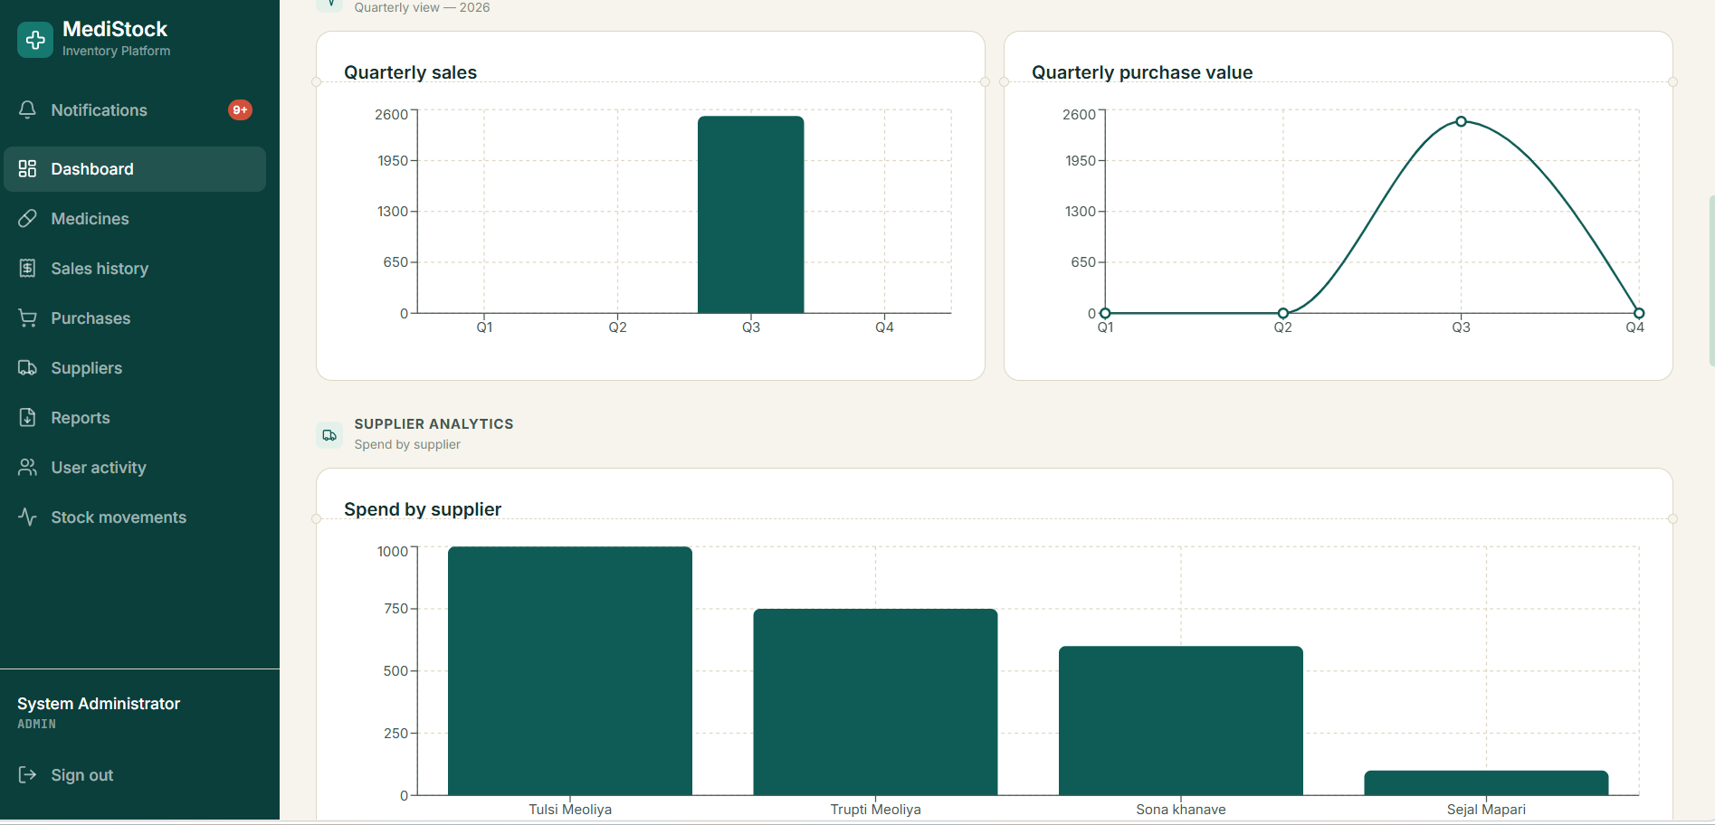
Fig 4.4 — Analytics dashboard: quarterly sales and purchase-value trends, and spend-by-supplier breakdown, computed live from database records.

4.5 Report Generation
The system provides report generation for both general inventory status and expiry-specific reporting. Users can generate an on-screen report and export it (e.g., as PDF/CSV) for record keeping, audits, or sharing with suppliers.
The expiry report lists all near-expiry and expired batches with quantities, so that these can be prioritized for return, discount sale, or disposal. The inventory report gives a full stock snapshot at the time of generation.
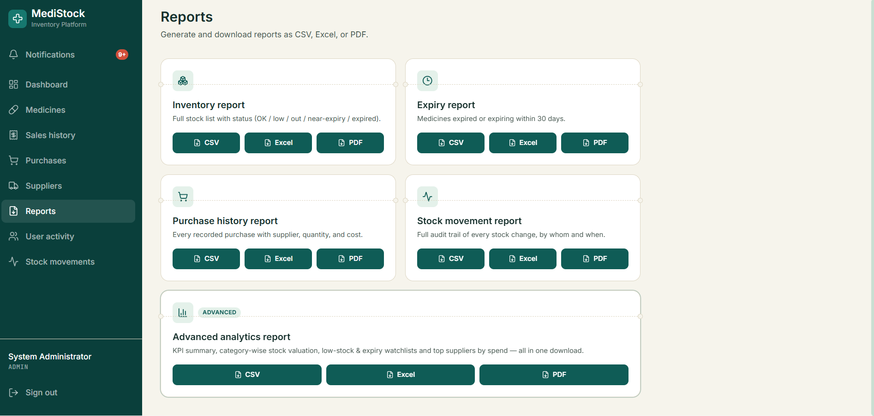
Fig 4.5 — Reports screen: Inventory, Expiry, Purchase-history, Stock-movement and Advanced-analytics reports, each exportable as CSV, Excel or PDF.

5. Testing & Demonstration
All features listed above were tested against the live application database rather than mock data, in line with the milestone requirement. Testing covered:
- Verifying expiry-status classification for batches with past, near, and future expiry dates.
- Verifying low-stock and out-of-stock flags after simulated stock-in and stock-out operations.
- Confirming notifications are generated correctly and do not duplicate for the same open issue.
- Cross-checking analytics API output (totals, counts) against the underlying database records.
- Generating sample inventory and expiry reports and validating the exported file content.
These features were demonstrated end-to-end — from the underlying database record, through the backend API response, to the corresponding frontend screen — ahead of the milestone review.

6. Conclusion
With Milestone 3 complete, the Medicine Inventory and Supplier Management System is now capable of actively monitoring stock and expiry conditions, alerting staff to issues that need attention, summarizing inventory health through analytics, and producing exportable reports — all working against real database data and integrated with the frontend, as targeted for the Week 6 deliverable.
This lays the groundwork for the next milestone, which can build further on these analytics and notification foundations.

